# IoT Based Smart Agriculture System

**Prepared by:**

**Tushar Chalwa**

|  |
| --- |
| *Executive Summary* |
| This report provides details of the Industrial Internship provided by upskill Campus and The IoT Academy in collaboration with Industrial Partner UniConverge Technologies Pvt Ltd (UCT).  This internship was focused on a project/problem statement provided by UCT. We had to finish the project including the report in 6 weeks’ time.  My project was (IoT Based Smart Agriculture System)  This internship gave me a very good opportunity to get exposure to Industrial problems and design/implement solution for that. It was an overall great experience to have this internship. |

**TABLE OF CONTENTS**

1 Preface 3

2 Introduction………………………………………………………………………………………………………………………………………..5

2.1 About Unicoverage Technologies Pvt Ltd……………………………………….…………………………………………...5

2.2 About upSkill Campus 10

2.3 Objective 12

2.4 Reference 12

3 Problem Statement 13

4 Existing and Proposed solution 15

5 Proposed Design/ Model 20

6 Performance Test 22

6.1 Test Plan/Test Cases……………………………………………………………………………………………………………………22

6.2 Test Procedures……………………………………………….. ……………………………………………………………………….23

6.3 Performance Outcome………………………………………………………………………………………………………………24

7 My learnings 25

8 Future work scope 26

# Preface

**Summary of the whole 6 weeks’ work:**

The project aims at making use of evolving technology i.e. IoT and smart agriculture using automation. Monitoring environmental factors are the major factor to improve the yield of efficient crops. The feature of this project includes monitoring temperature, humidity, and moisture in the agricultural field through sensors DHT11, YL69. It will turn ON/OFF motor based on soil moisture.

**About need of relevant Internship in career development**.

Having a relevant internship can play a crucial role in career development for several reasons.

1. Hands-on Experience
2. Skill Development
3. Industry Insights
4. Networking Opportunities
5. Resume Enhancement

**Opportunity given by USC/UCT.**

The Upskill is a platform where the learners can apply their learnings and give them an opportunity to showcase their learnings.

**How Program was planned**

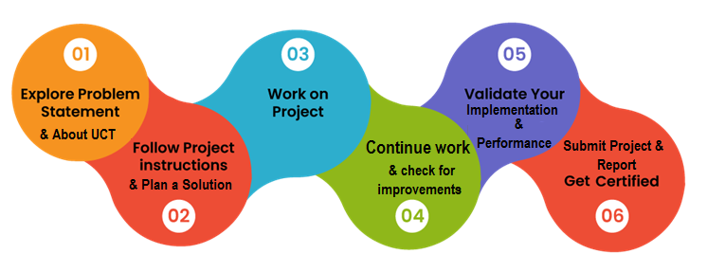

I learnt lot of things from this internship program and has increased my skillset.

Thanks to IoT Academy for helping me in this throughout journey.

I want to give message to my juniors to do some practical work by applying their learnings which they have taken in their throughout carrier and upskill is the best place to apply their learnings.I want all my seniors and juniors to enroll in this internship program by upskill and IoT academy.It helped me a lot.

# Introduction

## About UniConverge Technologies Pvt Ltd

A company established in 2013 and working in Digital Transformation domain and providing Industrial solutions with prime focus on sustainability and RoI.

For developing its products and solutions it is leveraging various**Cutting Edge Technologies e.g. Internet of Things (IoT), Cyber Security, Cloud computing (AWS, Azure), Machine Learning, Communication Technologies (4G/5G/LoRaWAN), Java Full Stack, Python, Front end**etc.

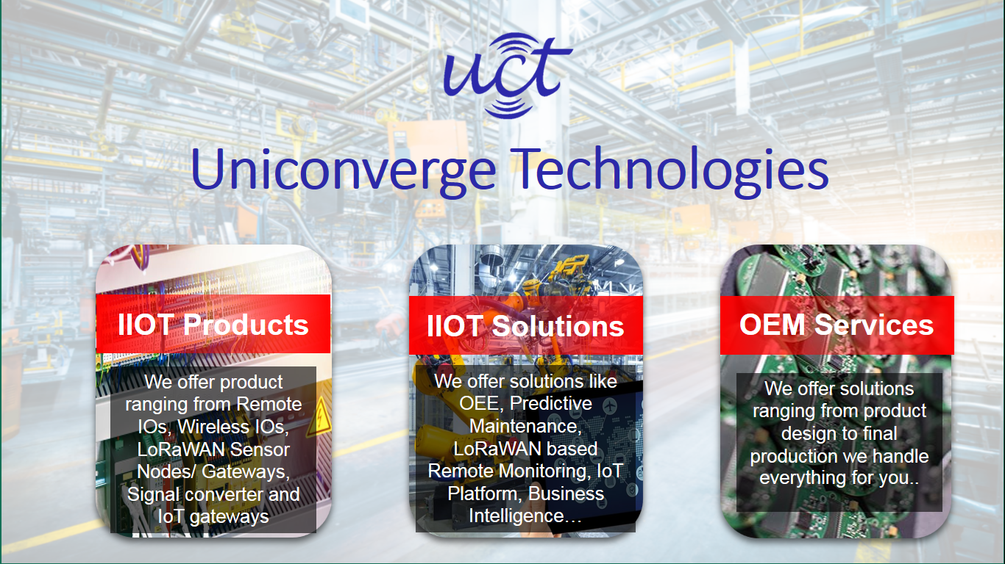

1. UCT IoT Platform **(****)**

**UCT Insight** is an IOT platform designed for quick deployment of IOT applications on the same time providing valuable “insight” for your process/business. It has been built in Java for backend and ReactJS for Front end. It has support for MySQL and various NoSql Databases.

* It enables device connectivity via industry standard IoT protocols - MQTT, CoAP, HTTP, Modbus TCP, OPC UA
* It supports both cloud and on-premises deployments.

It has features to  
• Build Your own dashboard  
• Analytics and Reporting  
• Alert and Notification  
• Integration with third party application(Power BI, SAP, ERP)  
• Rule Engine

 

1. **Smart Factory Platform (****)**

Factory watch is a platform for smart factory needs.

It provides Users/ Factory

* with a scalable solution for their Production and asset monitoring
* OEE and predictive maintenance solution scaling up to digital twin for your assets.
* to unleased the true potential of the data that their machines are generating and helps to identify the KPIs and also improve them.
* A modular architecture that allows users to choose the service that they what to start and then can scale to more complex solutions as per their demands.

Its unique SaaS model helps users to save time, cost and money.

 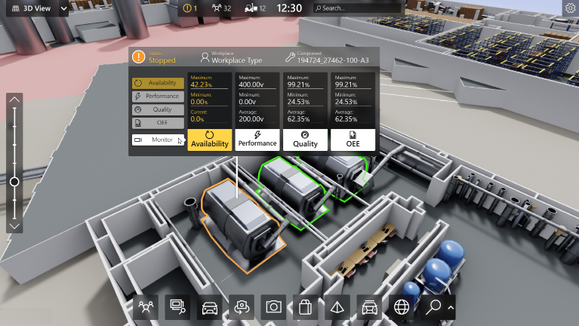

1. 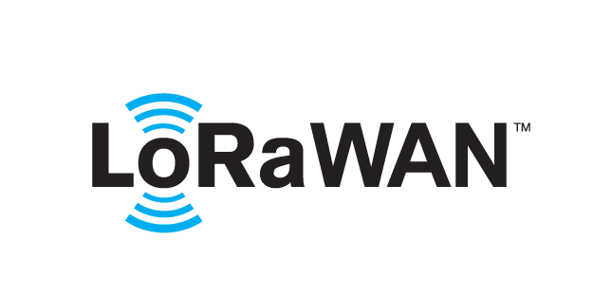 based Solution

UCT is one of the early adopters of LoRAWAN teschnology and providing solution in Agritech, Smart cities, Industrial Monitoring, Smart Street Light, Smart Water/ Gas/ Electricity metering solutions etc.

1. Predictive Maintenance

UCT is providing Industrial Machine health monitoring and Predictive maintenance solution leveraging Embedded system, Industrial IoT and Machine Learning Technologies by finding Remaining useful life time of various Machines used in production process.



## About upskill Campus (USC)

upskill Campus along with The IoT Academy and in association with Uniconverge technologies has facilitated the smooth execution of the complete internship process.

USC is a career development platform that delivers **personalized executive coaching** in a more affordable, scalable and measurable way.



Seeing need of upskilling in self paced manner along-with additional support services e.g. Internship, projects, interaction with Industry experts, Career growth Services

<https://www.upskillcampus.com/>

upSkill Campus aiming to upskill 1 million learners in next 5 year

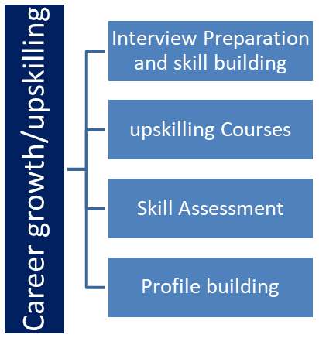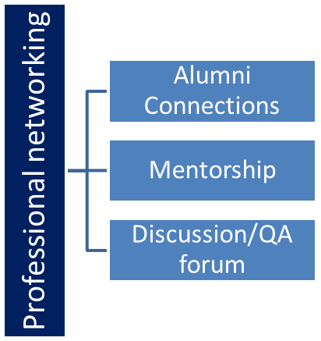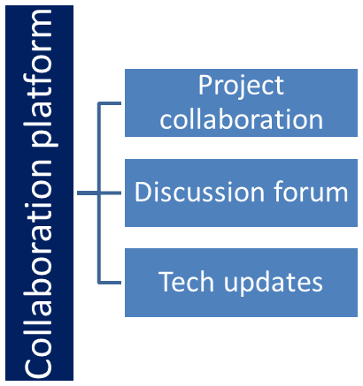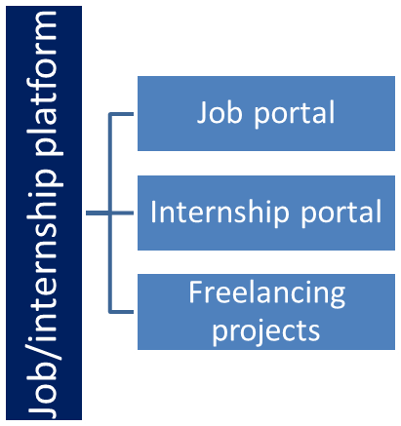

## The IoT Academy

The IoT academy is EdTech Division of UCT that is running long executive certification programs in collaboration with EICT Academy, IITK, IITR and IITG in multiple domains.

## Objectives of this Internship program

The objective for this internship program was to

 ☛ get practical experience of working in the industry.

 ☛ to solve real world problems.

 ☛ to have improved job prospects.

 ☛ to have Improved understanding of our field and its applications.

 ☛ to have Personal growth like better communication and problem solving.

## Reference

Smith, J., & Johnson, A. (2022). Smart Agriculture and IoT Technologies: Enhancing Crop Yield and Quality. Springer.

Brown, R., et al. (2021). "Environmental Monitoring in Precision Agriculture using IoT Devices." Journal of Agriculture Technology, 12(3), 45-58.

# Problem Statement

**Agriculture plays a vital role in the development of our country. Some issues concerning agriculture have been always hindering the development of our country. Develop a project related to smart agriculture IOT devices that can be used to offer assistance to farmers in getting Live Data Temperature, Humidity, Soil Moisture, and Soil Temperature for efficient environment monitoring which will enable them to increase their overall yield and quality of products.**

**Pages shown in this project are:-**

1. **MQTT Connection Page**

This page allows you to connect to an MQTT broker. It includes the following fields:

* Client ID: A unique identifier for your client.
* Server: The address of the MQTT broker.
* Port: The port number of the MQTT broker.
* Connect: Click this button to connect to the MQTT broker.
* Disconnect: Click this button to disconnect from the MQTT broker.

1. **Subscribe and Publish Page**

This page allows you to subscribe to and publish messages on MQTT topics. It includes the following fields:

* Topic: The topic to subscribe to or publish to.
* QOS: The quality of service (QOS) level for the subscription or publication.
* Message: The message to publish.
* Subscribe: Click this button to subscribe to the topic.
* Publish: Click this button to publish the message.

1. **Real-time dashboard**

This page displays real-time data on soil moisture, temperature, humidity, and soil temperature. This data can be used to track water usage and identify potential problems, such as leaks or low soil moisture levels.

1. **Control pump Page**

This page allows users to control the pump on or off. If the soil moisture level goes below a certain threshold, the pump will automatically start. This helps to ensure that plants have the water they need to thrive.

These two pages are essential for managing a smart water meter system. By providing users with real-time data and control over the pump, these pages can help to improve water conservation and efficiency.

# Existing and Proposed solution

Existing solutions for smart agriculture IoT projects that offer assistance to farmers with real-time data for temperature, humidity, soil moisture, and soil temperature monitoring can be found in the market. These solutions typically involve the use of various IoT devices, sensors, and software platforms. Here's a summary of some common existing solutions and their limitations:

**Commercial IoT Sensor Systems:**

* Many companies offer pre-built IoT sensor systems specifically designed for agriculture. These systems come with a range of sensors to monitor environmental parameters and connect to cloud-based platforms for data visualization.
* Limitations:
  + Costly: Commercial solutions can be expensive, making them less accessible to small-scale farmers or those with limited budgets.
  + Limited Customization: Farmers may not have the flexibility to customize the system to their specific needs or integrate it with their existing equipment**.**

**Mobile Apps for Environmental Monitoring:**

There are mobile applications that provide real-time environmental data to farmers. These apps often use weather data and GPS information to offer localized insights.

Limitations:

Limited Scope: Mobile apps may not provide on-ground data from sensors on the farm, relying instead on weather data that may not be as precise for localized monitoring.

Dependency on Internet Connectivity: Mobile apps heavily rely on internet connectivity, which may be an issue in remote farming areas with poor network coverage.

**My propsed Solution is:**

#### Component Used:

**• Relay:** A relay is an electrically operated switch. It means that it can be turned on or off, letting the current going through or not. when a relay contact is normally open (NO), there is an open contact when the relay is not energized. When a relay contact is Normally Closed (NC), there is a closed contact when the relay is energized.

**• ESP8266 ESP-01**

### Raspberry Pi as a Broker:

MQTT (Message Queue Telemetry Transport) is a lightweight messaging protocol for small devices and sensors. It is a publisher-Subscriber based model. A publisher can publish data to broker and subscribers can subscribe topic from the broker. So, the broker plays a very important role as a middle man.

In this project, we are creating raspberry pi as a broker. To make it broker, we are using a Mosquitto MQTT i.e open-source implementation of a message broker. Raspberry Pi as a broker receives Temperature and Humidity data with a specific topic from the Arduino microcontroller as described in module1 and also receives soil moisture data with topic information as mentioned in module 2.

Now subscriber as module 3 here can subscribe to data from the broker by specifying the topic name.

Using DIY Arduino/Raspberry Pi solutions for your smart agriculture IoT project gives you the advantage of customization and flexibility. To make DIY solution stand out and become better than other existing solutions, you can consider adding the following value:

1. Affordability: One of the significant advantages of DIY solutions is the potential cost-effectiveness. Focus on designing a system that is affordable and accessible to a broader range of farmers, including those with limited resources.
2. Modularity and Scalability: Create a modular system that allows farmers to start small and expand their setup as needed. This scalability can cater to the needs of both small-scale and large-scale farmers.
3. Localized Data Collection: Ensure that DIY system provides real-time, on-ground data from the farm itself rather than relying solely on external weather data. Localized data can offer more precise insights for farmers' decision-making.
4. Integration with Existing Equipment: Enable seamless integration of your DIY solution with existing agricultural equipment, such as irrigation systems and fertilization tools. This feature can make it easier for farmers to adopt and use your system effectively.
5. Energy Efficiency: Optimize the power consumption of DIY solution, allowing it to run on low power sources such as solar panels or batteries. Energy-efficient systems reduce operational costs and are environmentally friendly.
6. User-Friendly Interface: Design a user interface that is intuitive, easy to navigate, and accessible via mobile devices. Farmers should be able to access and interpret data effortlessly.
7. Data Analysis and Insights: Provide farmers with data analysis tools and actionable insights based on the collected data. This feature can help them make informed decisions to improve their agricultural practices.
8. Offline Functionality: Incorporate offline functionality in DIY system so that farmers can continue using it even in areas with poor or no internet connectivity.
9. Remote Monitoring and Alerts: Implement remote monitoring capabilities, allowing farmers to access real-time data and receive alerts on their smartphones, even when they are away from the farm.
10. Community and Support: Create a community around your DIY solution, offering support forums, tutorials, and resources to help farmers make the most of the technology.

## Code submission : <https://github.com/TUSHAR-30/upskill_campus>

## Report submission (Github link) : <https://github.com/TUSHAR-30/upskill_campus>

# Proposed Design/ Model

Module Details:

**Module-1:**

In the first module we are using ESP8266 Wi-Fi module that will act as a microcontroller and it will attached to a DHT11 to sense the current temperature and humidity. The module will publish the temperature and humidity data to MQTT broker i.e Raspberry Pi.

**Component Used:**

* **ESP8266 ESP-01:** It is low power consuming Wi-Fi module with integrated TCP/IP protocol stack that can give any microcontroller access to WiFi network. It is self-contained SOC (System On a Chip) that doesn’t necessarily need a microcontroller to manipulate inputs and outputs.
* **DHT11:** It is a temperature and humidity sensor that generates calibrated digital output for temperature and humidity. It uses a humidity sensor and thermistor to measure surrounding environment. It has fast response and excellent quality.

**Module-2:**

In the second module we are using Arduino as a microcontroller that will get the soil moisture through a moisture sensor and publish it to MQTT broker by using ESP8266 Wi-Fi module.

**Component Used:**

* **Arduino Uno:** It is a microcontroller board based on the ATmega328. It has 14 digital I/O pins and 6 analog pins. It just need to connect with computer with a USB cable to upload the code and powered through a AC to DC adapter or a battery.
* **YL-69:** It is soil moisture sensor used to measure water content of soil. It can detect whether the soil is too dry or wet. This sensor uses the two probes to pass current through the soil, and then it reads that resistance to get the moisture level.
* **ESP8266 ESP-01**

**Module-3:**

In this module ESP8266 WiFi Module works as a subscriber who subscribes the moisture data from the MQTT Broker(Rasberry Pi). ESP8266 connected to relay i.e connected to motor and it will turn motor ON/OFF on the basis of soil moisture.

# Performance Test

Developing a smart agriculture IoT project to provide real-time data for temperature, humidity, soil moisture, and soil temperature requires careful testing to ensure its effectiveness, reliability, and usability. Below are some possible test cases, test procedures, and performance outcomes for the given problem:

1. **Hardware Testing:**
   * Test all IoT devices (sensors) to ensure they are functioning correctly and accurately measure the environmental parameters (temperature, humidity, soil moisture, and soil temperature).
   * Check for any hardware defects, connectivity issues, or data transmission problems.
   * Verify that the IoT devices can withstand outdoor conditions and are durable enough to withstand farming environments.
2. **Software Testing:**
   * Test the software interface that displays the real-time data from the IoT devices to ensure it is user-friendly and easy to navigate for farmers.
   * Check for any bugs or glitches in the software that could affect data accuracy or cause the system to crash.
   * Validate the data storage and retrieval processes to ensure that historical data is properly recorded and accessible when needed.
3. **Data Accuracy Testing:**
   * Compare the data obtained from the IoT devices with manual measurements to verify the accuracy of the sensors.
   * Test the system's ability to detect and handle outliers or abnormal data values.

**Test Procedures:**

**Sensor Calibration Test Procedure:**

Set up known reference values for temperature, humidity, soil moisture, and soil temperature.

Compare the sensor readings with the reference values to check for accuracy and calibration.

Adjust the sensor calibration if necessary to ensure accurate measurements.

**Data Transmission Test Procedure:**

Simulate various environmental conditions and verify that the sensors transmit data correctly to the central system (e.g., Raspberry Pi or cloud server).

Monitor data transmission stability and identify any potential data loss or corruption issues.

**Data Storage and Retrieval Test Procedure:**

Test data storage by collecting sample data from the sensors and ensuring it is correctly stored in the database or memory.

Retrieve the stored data and verify its accuracy to ensure proper data recording and retrieval.

**Performance Outcomes**:

* The smart agriculture IoT system should provide real-time and accurate data on temperature, humidity, soil moisture, and soil temperature to farmers.
* Farmers should be able to access the data from anywhere and at any time through a user-friendly interface (mobile app or web portal).
* The system should be able to handle a large number of IoT devices simultaneously, especially in large farms or plantations.
* The data transmission and retrieval processes should be fast and responsive.
* The IoT devices should have a long battery life to minimize maintenance efforts.
* The smart agriculture system should help farmers make informed decisions regarding irrigation, fertilization, and other farming practices to increase their overall yield and product quality.

By conducting rigorous testing and ensuring these performance outcomes, the smart agriculture IoT project can offer valuable assistance to farmers, leading to more efficient environment monitoring and increased agricultural productivity.

# My learnings

1. **IoT Technology:**I learn about Internet of Things (IoT) concepts, including sensor technology, data transmission protocols, connectivity options, and hardware-software integration.
2. **Agricultural Domain Knowledge:** I gain insights into the agricultural industry, farming practices, and the importance of environmental monitoring in optimizing crop yield and quality.
3. **Project Management:** Planning and executing the project teaches me a valuable project management skills, such as setting goals, defining requirements, creating a timeline, and managing resources effectively.
4. **Hardware and Software Development:** I have the opportunity to work on both hardware (IoT devices/sensors) and software (user interface, data storage, and analysis) components of the system.
5. **Problem-Solving Skills:** As i encounter challenges during the project, i develop problem-solving skills to troubleshoot hardware issues, software bugs, and connectivity problems.
6. **Data Analysis:** I learn how to process and analyze the data collected from the sensors to derive meaningful insights and make data-driven decisions.
7. **User Experience (UX) Design:** Creating a user-friendly interface for farmers to access and interpret the data gives me insights into UX design principles.
8. **Testing and Quality Assurance:** Developing test cases and procedures teaches how to ensure the system's reliability, accuracy, and performance.
9. **Communication and Collaboration:** I work with a team or interact with farmers and agricultural experts, improving your communication and collaboration skills.
10. **Adaptability and Flexibility:** Projects often encounter unexpected challenges; working on this project teaches me to be adaptable and flexible in finding solutions.
11. **Environmental Considerations:**I learn about the impact of weather and environmental factors on agricultural practices and how technology can mitigate risks.
12. **Real-World Application:** Developing a practical project with real-world implications gives me a sense of accomplishment and a better understanding of how technology can address real-life challenges.

# Future work scope

This system will include the intelligent system which will analyze the frequency of water supply to a specific crop on the basis of weather condition and will identify the amount of water required in the field to prevent the crop from damage and send this information to farmer via SMS or e-Mail to ensure the arrangement of enough water for healthy farming.

Machine learning can be used to detect unidentified objects like to prevent crops from animals using Camera Motion Sensor and further an image can be sent via MMS to farmer as alert message.